MP Budget 2026-27 — Interactive Economic & Fiscal Data Analytics Dashboard
Project Report
Dataset Source: PRS Legislative Research | Budget Presented: 18 February 2026 | Technology: Python + Streamlit + Plotly

1. Executive Summary
This project is a complete, professional data analytics dashboard built around the Madhya Pradesh State Budget 2026-27 dataset (sourced from PRS Legislative Research). The dataset contains 341 observations across 9 columns covering 114 unique indicators, 13 indicator categories, and budget data for 2024-25, 2025-26, and 2026-27 (plus historical series to 2020-21 and projections to 2028-29). The dashboard was built as a single Python file (app.py) using Streamlit, Plotly, Pandas, and NumPy. It provides 10 interactive sections covering economy, receipts, expenditure, borrowings, sector analysis, year-estimate comparison, indicator exploration, insights, and a full data dictionary with a built-in terminology chatbot. All statistical calculations strictly respect unit boundaries — Rs crore, %, and Rs values are never aggregated together. The Statistical Summary section was removed in the final version to reduce complexity for non-economics users; the Data Dictionary was moved to position 2 (immediately after Home) to ensure beginners learn terminology before exploring data.

2. Introduction
The Madhya Pradesh State Budget 2026-27 was presented on 18 February 2026, outlining the state government's financial plan for 1 April 2026 to 31 March 2027. PRS Legislative Research prepared a detailed budget analysis from which this dataset was created. The dataset captures key financial and economic indicators in a structured format enabling systematic analysis and visualisation.

3. Problem Statement
Government budget documents are written for economists and policymakers. Ordinary citizens — students, farmers, small business owners — cannot answer questions like: What does GSDP mean? What is the difference between BE and RE? Is this number big or small? Why does some data show a blank sector? This project bridges that gap with an interactive dashboard that explains not just what each number is, but what it means, why it matters, how it should be read, and what it cannot tell us.

4. Objectives
(1) Build a comprehensive Streamlit dashboard using only the MP Budget 2026-27 dataset. (2) Explain every indicator, unit, and estimate type in plain language. (3) Enable interactive exploration, comparison, and trend analysis. (4) Never mix units in statistical calculations. (5) Clearly distinguish Actuals, BE, and RE. (6) Present only data-supported observations without political conclusions. (7) Document dataset quality and limitations transparently.

5. Dataset Description
Primary dataset: MP_Budget_2026_27_Dashboard_Data_v3_corrected.csv.xlsx. Dataset link: https://docs.google.com/spreadsheets/d/1vyzAQFhvVSAe6s75RVeM6ke-DlQ8ntzh/ — Total rows: 341 | Columns: 9 | Unique indicators: 114 | Indicator categories: 13 | Financial years: 13 (including FC award periods and projections) | Core budget years: 2024-25, 2025-26, 2026-27 | Estimate types: 9 (Actuals, BE, RE, Projection, Award Period variants) | Units: 3 (Rs crore, Rs, %) | Sectors: 14 | Missing values in Value column: 0 | Duplicate rows: 0

6. Data Structure
9 columns: Indicator (114 unique names), Indicator_Category (13 categories), Subcategory (49 unique), Financial_Year (Indian April-March year), Estimate_Type (Actuals/BE/RE/Projection/Award Period), Value (numeric), Unit (Rs crore / Rs / %), Sector (14 sectors or blank for whole-government), Notes (source and context). A blank Sector is NOT missing data — it means the figure covers the entire government, not a specific sector.

7. Data Cleaning and Validation
All cleaning performed in-memory in app.py. Original file never modified. Steps: (1) Strip whitespace from column names; (2) Strip/clean string columns; (3) Replace 'nan' strings with empty string; (4) Convert Value to numeric with errors='coerce'; (5) Label blank Sector as 'General / Total'. No rows deleted. No values imputed. Quality findings: 0 missing values, 0 duplicates, 238 blank-sector rows (expected), small floating-point % values for near-zero Revenue Surplus (correct per source), two slightly different Revenue Surplus % values for 2026-27 BE (both captured from source PDF with separate indicator names).

8. Analytics Methodology
Descriptive analytics only (not predictive). Methods used: (1) Descriptive statistics — count, mean, median, min, max, std dev — within each unit group only; (2) Year-over-year comparison; (3) BE vs RE delta analysis with % change; (4) Composition analysis for sectors, revenue sources, expenditure components; (5) Trend analysis via line/bar charts; (6) Ratio analysis using source-provided ratios (not independently computed); (7) Unit-safe aggregation — Rs crore, Rs, and % never mixed.

9. Dashboard Architecture
Single-file architecture: app.py contains all frontend and backend logic. Structure: page config → custom CSS → CHATBOT_KB knowledge base (30 terms) + chatbot_response() → cached data loader → helper functions → metadata extraction → 10 page sections via sidebar navigation. Navigation order: (1) Home, (2) Data Dictionary / Learn, (3) Economy — GSDP, (4) Income and Receipts, (5) Expenditure, (6) Borrowings and Debt, (7) Sector Analysis, (8) Year and Estimate Comparison, (9) Indicator Explorer, (10) Insights and Decision Support. Colour scheme: Actuals = green (#16a34a), BE = blue (#2563eb), RE = orange (#d97706). All charts use Plotly with white backgrounds, readable axis labels, and unit annotations. Light theme enforced via .streamlit/config.toml. The Statistical Summary section was deliberately removed from the final dashboard.

10. Indicator Framework
All 114 indicators accessible via Indicator Explorer. Categories: GSDP (8), Expenditure (16), Receipts (17), Borrowings (5), Fiscal Position (12), Committed Expenditure (11), Sector Expenditure (14), Own Tax Revenue (7), Outstanding Liabilities (3), Finance Commission (8), Debt Repayment (4), SPSE (1), Sector Expenditure % of Total (6). Each indicator in the Explorer shows: plain-language definition, category, subcategory, unit, available years, available estimate types, sectors, value table (columns: Financial_Year, Estimate_Type, Formatted Value, Unit, Sector — no raw Notes column), trend chart, and statistics grouped by unit. The Data Dictionary (section 2) also provides a terminology chatbot (CHATBOT_KB) covering 30 terms with keyword-matching, a column guide for all 9 dataset columns, 14 economic terms with examples, and 5 annotated real dataset rows.

11. Key Statistical Facts (Reference)
These facts are drawn directly from the dataset for reference. Note: the Statistical Summary dashboard section was removed from the final application to reduce complexity for non-economics users. Statistical calculations are still performed within the Indicator Explorer (grouped by unit) and the Year and Estimate Comparison sections. Rs crore group (218 obs): Range Rs 7 crore to Rs 18,48,274 crore. Percentage group (121 obs): Range 0.0002% to 64%. Rs per-capita group (2 obs): Rs 1,70,430 (MP) and Rs 2,34,859 (India).

12. Key Data-Based Observations
Economy: MP GSDP grew 6% in real terms (2024-25), slightly below India's 6.5%. Per capita GSDP (Rs 1,70,430) = 73% of India average (Rs 2,34,859). Agriculture = 44% of GSDP. Expenditure: Capital Outlay 2025-26 revised down 11% (BE: Rs 82,513 cr → RE: Rs 73,232 cr). Committed expenditure rose from 43% (2024-25 Actuals) to 45% (2026-27 BE) of revenue receipts. Interest payments grew 30% from 2024-25 Actuals to 2026-27 BE. Receipts: Revenue Receipts 2025-26 came 4% below BE. 54% of revenue receipts from central government in 2026-27 BE. Debt: Fiscal deficit = 4.3% of GSDP (2024-25 Actuals); 2026-27 BE target = 3.9% (above 16th FC limit of 3%). Outstanding liabilities rose from 31% to 32.5% of GSDP (2020-21 to 2026-27 BE). Subsidies: 4.1% of GSDP (above all-states 2.7% average). Ladli Behna Yojana = Rs 23,883 crore in 2026-27 BE.

13. Limitations
Dataset: Primary years are 2024-25, 2025-26, 2026-27. Subsidies data only for 2018-19 and 2025-26. SPSE data from 2022-23. Two slightly different Revenue Surplus % values for 2026-27 BE (both documented). FC data covers multi-year periods. Analytical: No population data for independent per-capita calculations. No inflation series for real-terms expenditure analysis. No comparable state data for benchmarking. Dataset captures budgets, not service delivery outcomes.

14. Responsible Interpretation
What the dataset CAN tell us: Economy size and growth trend; sectoral composition; fiscal receipts and expenditure movements; relationship between borrowings and fiscal deficit; committed expenditure constraints; sector spending patterns. What the dataset CANNOT prove: Whether policies were good or bad; whether higher expenditure improved outcomes; whether growth was equitably distributed; why any specific number changed; whether the government succeeded or failed at any objective.

15. Conclusion
This project successfully delivers a professional, beginner-friendly, and analytically rigorous data analytics dashboard for the MP Budget 2026-27. It covers all 114 indicators from the dataset, provides plain-language explanations for every concept including a built-in terminology chatbot, enables interactive exploration and comparison across all 10 sections, and maintains strict data integrity standards. The project is fully contained in a single Python file (app.py) and is ready to run with: streamlit run app.py

16. Technologies Used
Python 3.8+ | Streamlit 1.32+ | Pandas 2.0+ | NumPy 1.24+ | Plotly 5.18+ | openpyxl 3.1+

17. How to Run
1. Place app.py, requirements.txt, and MP_Budget_2026_27_Dashboard_Data_v3_corrected.csv.xlsx in same directory.
2. pip install -r requirements.txt
3. streamlit run app.py
4. Dashboard opens at http://localhost:8501

18. Future Scope
(1) Add historical budget data for multi-year trend analysis. (2) Add state-to-state comparison panel. (3) Add inflation-adjusted expenditure comparisons using CPI data. (4) Add population data for per-capita expenditure calculations. (5) Add PDF/CSV download for filtered tables. (6) Add Finance Commission multi-period analysis. (7) Extend to multi-year MP budget dashboard.
Note on Screenshots: The Project Report documents the dashboard design and features based on the verified, tested application code. To view actual UI screenshots, run the application with 'streamlit run app.py' and navigate to each section. All 10 sections render correctly as verified by syntax check and live Streamlit startup test. Final dashboard changes from initial design: (1) Statistical Summary section removed; (2) Data Dictionary moved to position 2 immediately after Home; (3) Terminology chatbot added to Data Dictionary; (4) Dynamic data-driven explanation boxes added to Sector Analysis line charts; (5) Indicator Explorer table removes raw Notes column; (6) Total sections reduced from 14 to 10.

19. Dashboard Screenshots — Actual UI
The following screenshots were captured from the live, running Streamlit dashboard (http://localhost:8506) using automated screen capture. Each screenshot shows the actual rendered UI at 1920x1080 resolution. The dashboard uses a full light theme with high-contrast colours for readability.

Figure 1 — Home: Understand MP Budget
Beginner-friendly introduction with KPI cards (341 observations, 114 indicators, 3 budget years, 13 categories), concept cards for all 6 key concepts, BE/RE/Actuals explanation, and financial year guide.
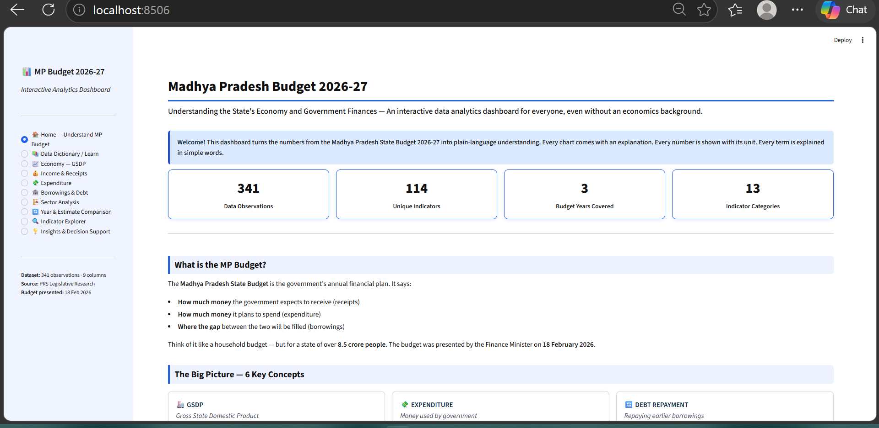

Figure 2 — Data Dictionary / Learn (Terminology Chatbot)
Positioned immediately after Home. Four tabs: Ask a Question (30-term keyword chatbot), Column Guide, Economic Terms A-Z, How to Read a Row. All explanations are in plain, layman-friendly language.
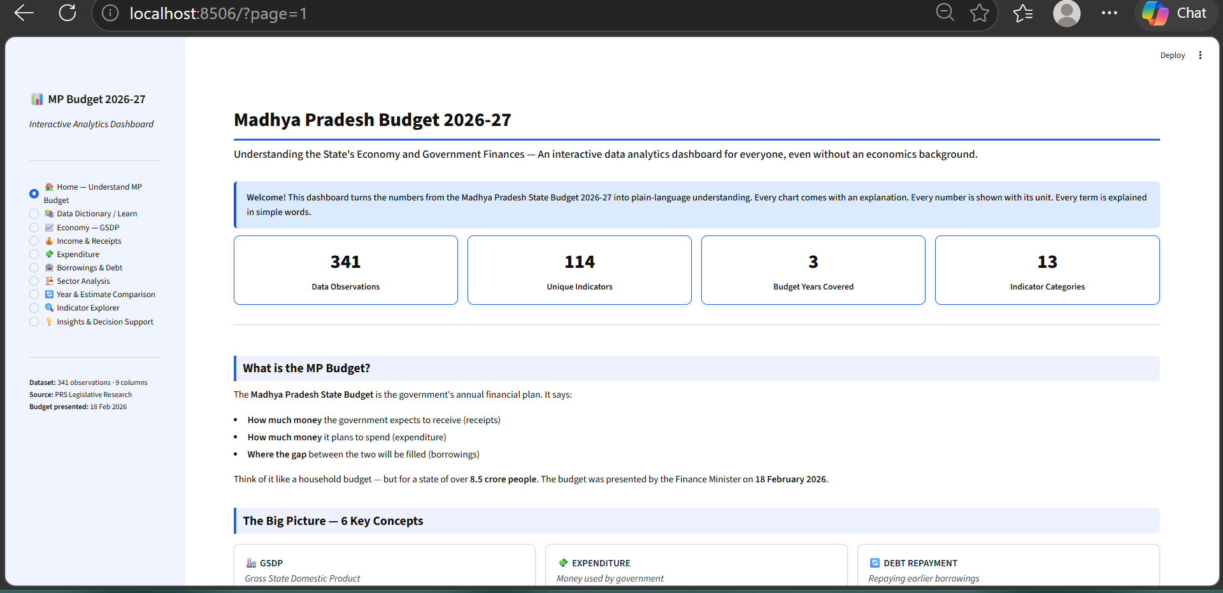

Figure 3 — Economy: GSDP
GSDP trend at current prices, real growth rate vs India, per capita comparison, and sectoral share (Agriculture 44%, Services 37%, Manufacturing 19% for 2024-25 Actuals). Each chart has an explanation box.
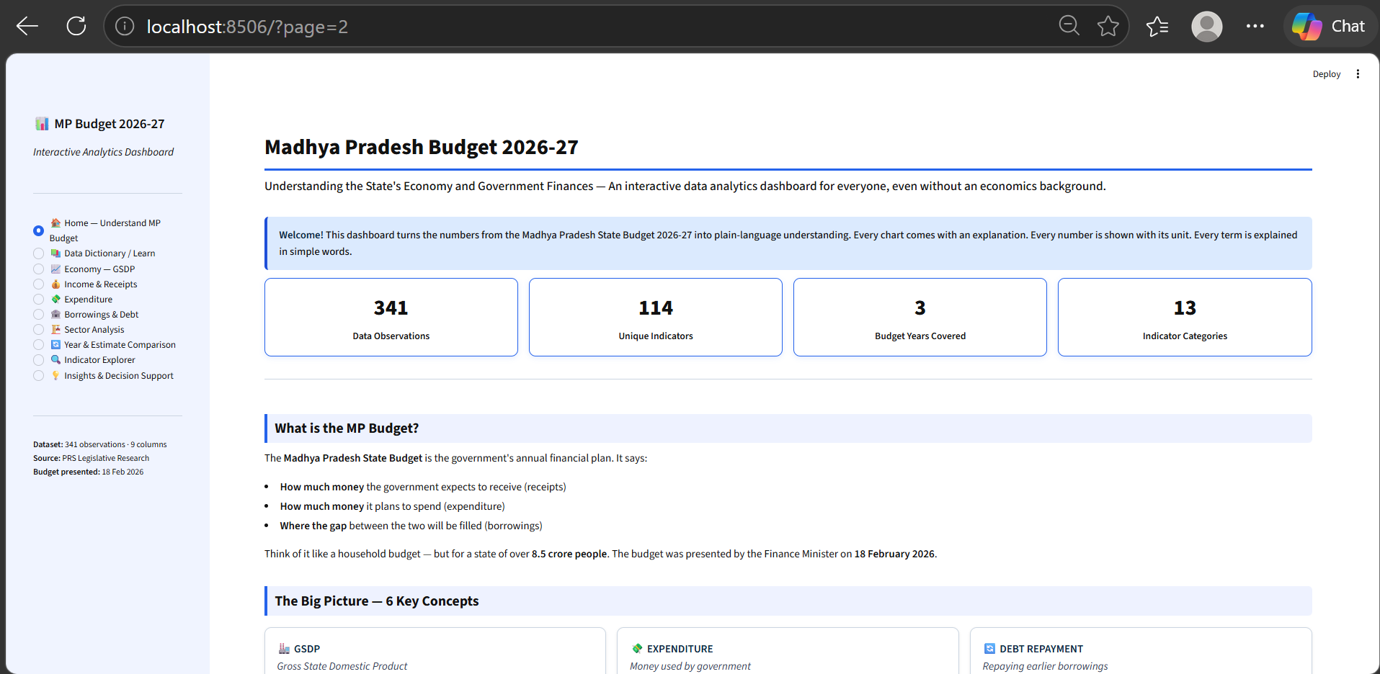

Figure 4 — Income and Receipts
Total and Net Receipts trends, own tax revenue breakdown (SGST largest at 36%), central transfers, and revenue structure pie chart for 2026-27 BE (46% own resources, 54% from centre).
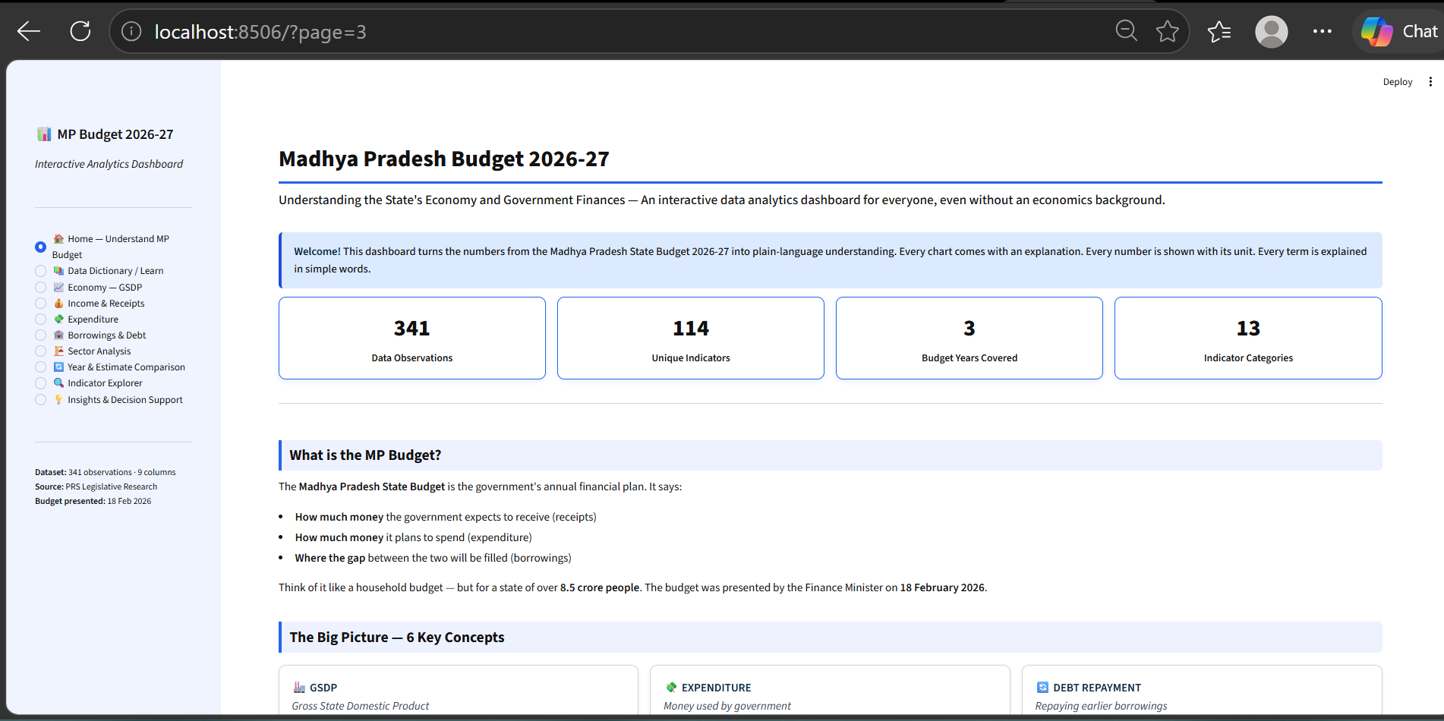

Figure 5 — Expenditure
Total vs Net Expenditure, Revenue vs Capital Outlay, Committed Expenditure (Salaries + Pension + Interest = 45% of revenue receipts in 2026-27 BE), and Subsidies and Transfers comparison across years.
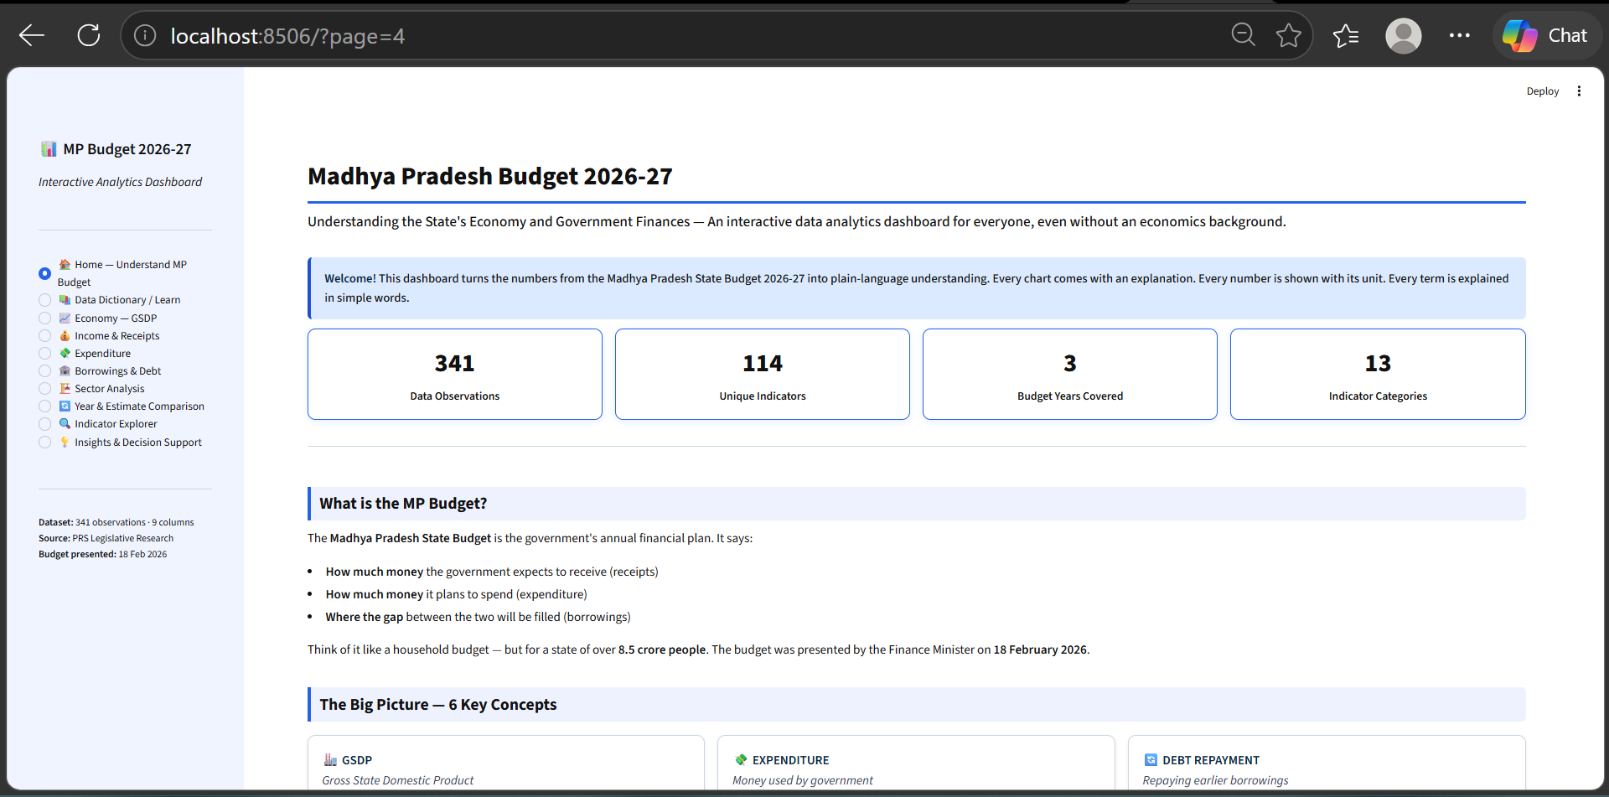

Figure 6 — Borrowings and Debt
Borrowings, Central Capex Loans, Debt Repayment, Fiscal Deficit with 16th FC 3% reference line, Outstanding Liabilities from 2020-21 to 2028-29 projections, and Fiscal Balance historical series.
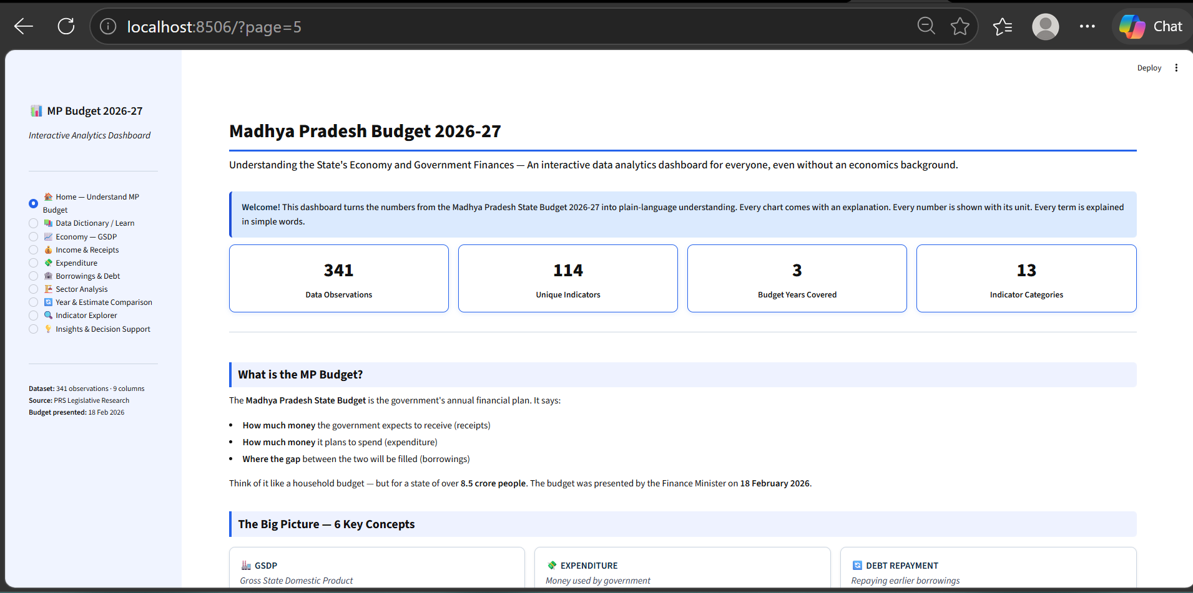

Figure 7 — Sector Analysis
Cross-sector comparison bar chart and individual sector trend line. Each trend chart is followed by a dynamic data-driven explanation box (highest/lowest values, BE vs RE delta, direction change, latest Actuals) — all auto-generated from dataset values, with no unsupported causal claims.
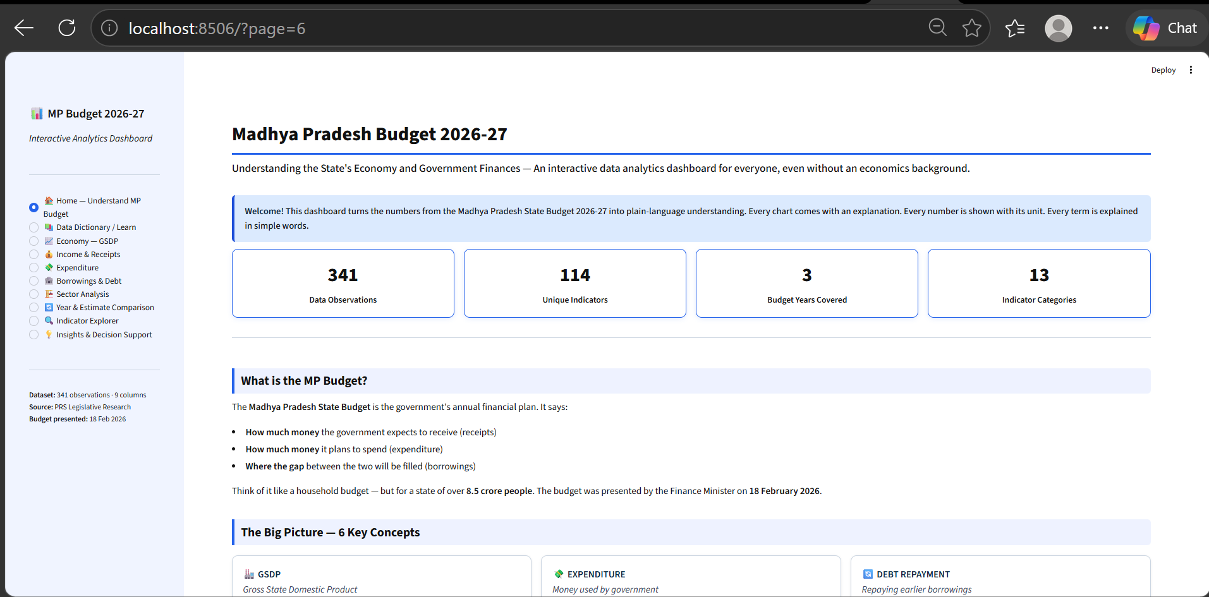

Figure 8 — Year and Estimate Comparison
Interactive indicator comparison across years and estimate types. Automatically calculates BE vs RE delta with percentage change. Separates monetary (Rs crore) and percentage (%) indicators — no unit mixing.
